

**ORCHESTRATE Dashboard User Guide**

**Table of Contents**

1. Accessing the ORCHESTRATE Dashboard(s) 2 - 3
2. Navigating the ORCHESTRATE Dashboard(s) 4 - 6
3. Using and Customizing ‘Pulse’ 7 – 11
4. What is ‘Pulse’
5. How to use ‘Pulse’
6. How to customize your automated ‘Pulse’ digest
7. ORCHESTRATE Optimize Feature 12-18
   1. What is ORCHESTRATE Optimize
   2. How to use ORCHESTRATE Optimize
   3. How to read ORCHESTRATE Optimize Results
   4. How to access Salesforce Einstein for ORCHESTRATE Optimize
8. **Accessing the ORCHESTRATE Dashboard(s)**

Please follow the instructions below to access dashboards. Users should receive an email from Tableau and/or Microsoft on this topic, but it is not necessary to click on these emails. Those are a formality to help get users to the correct sign on site, but the instructions below also get you there.

1. Navigate to the tableau single sign on (SSO) site: [**https://us-east-1.online.tableau.com/#/site/eversanaorchestrate/home**](https://us-east-1.online.tableau.com/#/site/eversanaorchestrate/home)

Add your EVERSANA email, check “remember me”, and hit **Sign In**

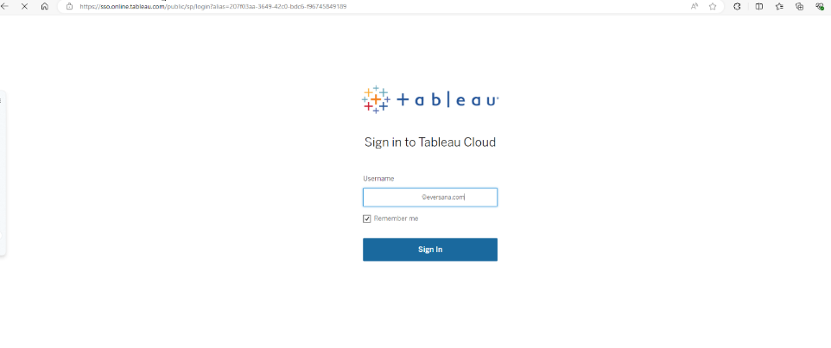

**If you are a first time EVERSANA Tableau Cloud user**, you will see one additional popup. Simply hit **Accept** to continue. You will not be asked this again.

If you are asked for a **URI**, please type in “eversanaorchestrate”.

1. Toggle to Eversana Orchestrate. From the home screen, you can click on the Explore Navigation to view the folders you have access to. Click on the folder for your account/brand and navigate to your dashboard.

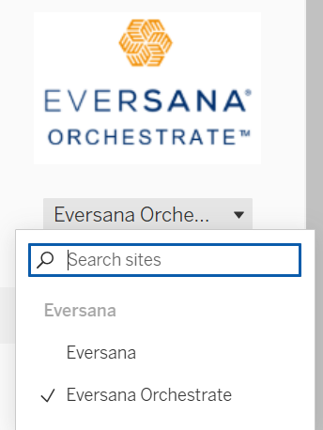

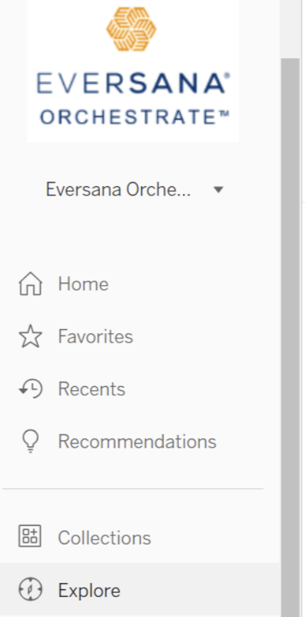

**TIP:** Once in your dashboard, bookmark the dashboard URL for easy access.

1. **Navigating the ORCHESTRATE Dashboard(s)**

**Field Force Dashboard**

Once the dashboard is opened, this is the main screen that will appear for “Field”:

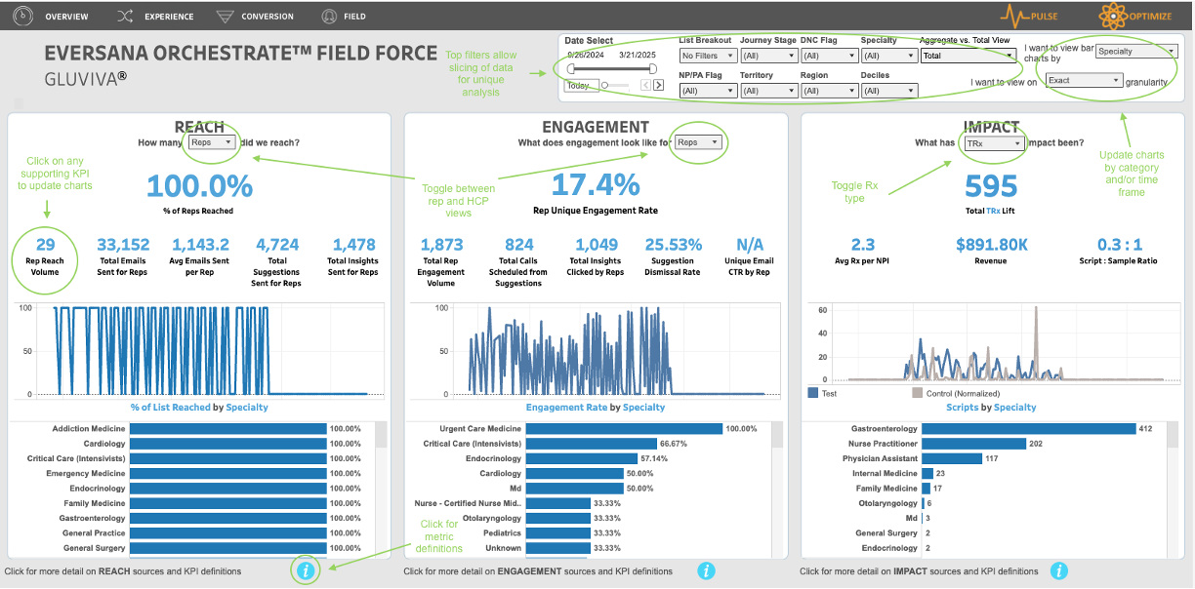

*ORCHESTRATE Field dash functionality and user guide:*

* Data can be sliced and analyzed by date range/time period granularity as well as by multiple filters found in the top right on the dashboard.
* Filters are located in the top-right of dash. When a filter is selected, it will apply to the full dashboard.
* In the filter section, users have the ability to change the granularity of the trend charts (yearly, monthly, or daily aka exact). Dash will show daily by default.
* In the filter section, users can change the horizontal bar chart breakout (dash will show specialty by default).
* In most sections and KPIs, users can hover over areas in the charts for additional data points.
* Drop selects in each section update the metrics within that corresponding section. For example, if user selects “Reps” in the REACH or ENGAGEMENT section, the KPIs update to sales rep specific KPIs. If the user selects “HCPs”, the KPIs update to HCP specific KPIs. And if the user selects NBRx vs NRx, vs TRx, KPIs in the IMPACT section update accordingly.
* In all visuals, the user can select a value to highlight it for better visibility. To un-highlight, simply select that value again.
* **Definitions for all metrics can be found in the bottom information circles.**

**Experience Dashboard**

Once the dashboard is opened, this is the main screen that will appear for “Experience”:

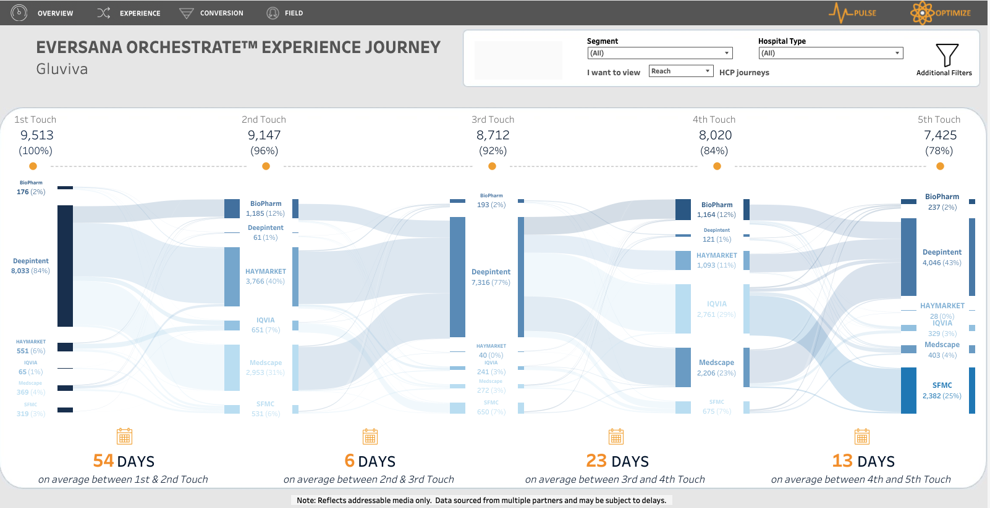

*ORCHESTRATE Experience dash functionality and user guide:*

* Filters are located in the top-right of dash. When a filter is selected, it will apply to the full dashboard.
* 1st touch relates to the segment HCPs were in at the start of the ORCHESTRATE campaign.
* 2nd touch and onward shows how an HCP moves along their experience or journey, based on segmentation specific logic.
* This visual not only shows volume in transitions, but also shows the time between stages.
* The first 5 touches display in this dashboard.
* HCPs can move forward or backwards in their journey stages.

**NPP Dashboard**

Once the dashboard is opened, this is the main screen that will appear for “Overview”:

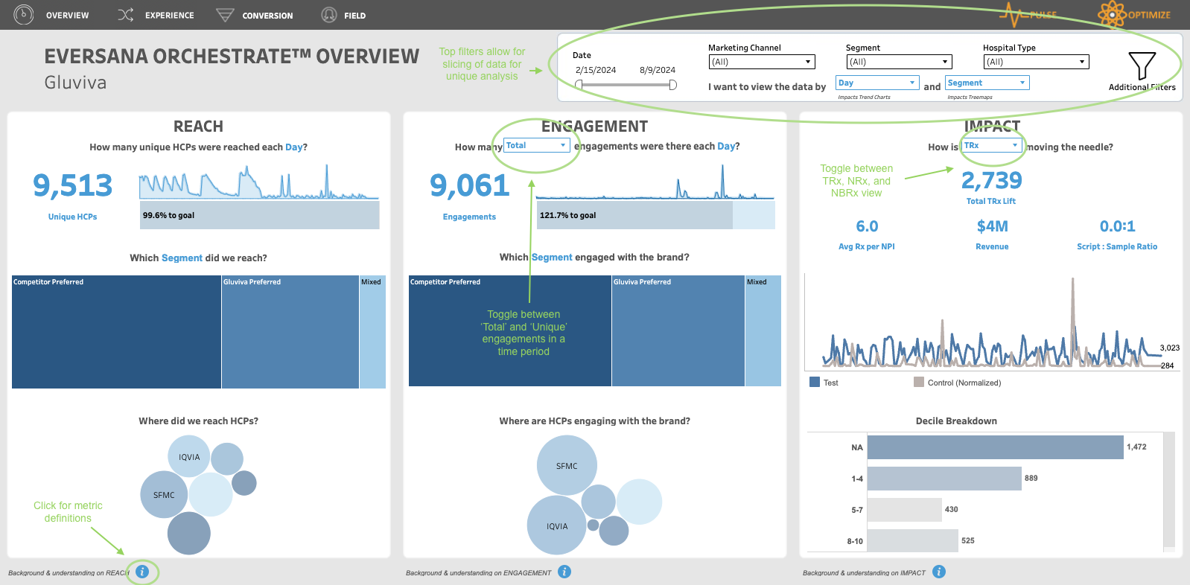

*ORCHESTRATE NPP dash functionality and user guide:*

* Data can be sliced and analyzed by date range/time period granularity as well as by multiple filters found in the top right on the dashboard.
* When a filter is selected, it will apply to the full dashboard.
* In the filter section, users have the ability to change the granularity of the trend charts (monthly, weekly or daily aka exact). Dash will show daily by default.
* In the filter section, users can change the treemap breakout.
* In most sections and KPIs, users can hover over areas in the charts for additional data points.
* Drop selects in each section update the metrics within that corresponding section. For example, if user selects “Total” in the ENGAGEMENT section, the KPIs update to KPIs on total engagement. If the user selects “Unique”, the KPIs update to KPIs on unique engagement. And if the user selects NBRx vs NRx, vs TRx, KPIs in the IMPACT section update accordingly.
* In all visuals, the user can select a value to highlight it for better visibility. To un-highlight, simply select that value again.
* **Definitions for all metrics can be found in the bottom information circles.**

**III. Using and Customizing ‘Pulse’**

**What is ‘Pulse’?**

Pulse is a Tableau generative AI feature for a more immersive and insightful experience into the data. Instead of a developer building visuals for the user, the developer simply defines metrics that the user is interested in tracking, and Pulse does the rest. The platform automatically generates insights and visuals that showcase points of interest with respect to that metric.

**How to use ‘Pulse’**

Pulse is easy to navigate to within the ORCHESTRATE dashboard and enables users to customize what they follow for a more relevant, valuable experience.

To navigate to Pulse, simply click the ‘Pulse’ button on the top right of the dashboard.



The Pulse home screen will appear.

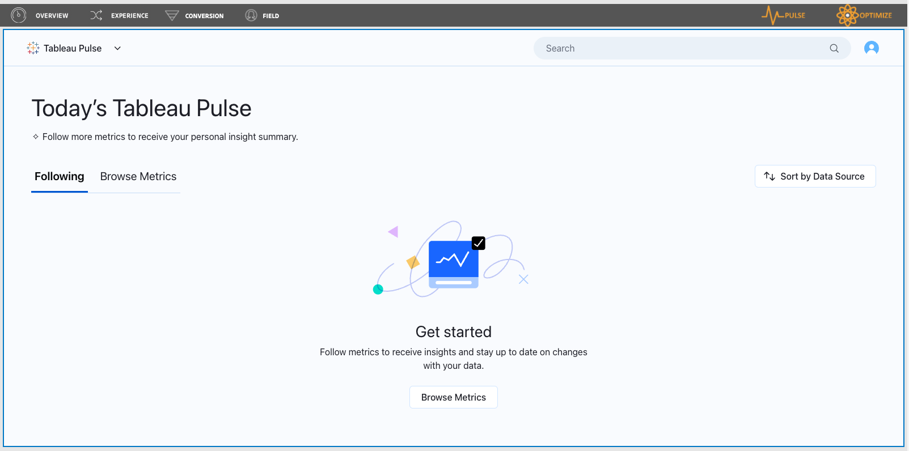

The first time a user logs in there won’t be any metrics showing; this is because a user needs to setup metrics to follow. For first time users, navigate to “Browse Metrics” and select which metrics to follow in Pulse.

To follow metrics, click on “Browse Metrics” from the Pulse Homepage. This will display the full list of metrics available to customize to follow:

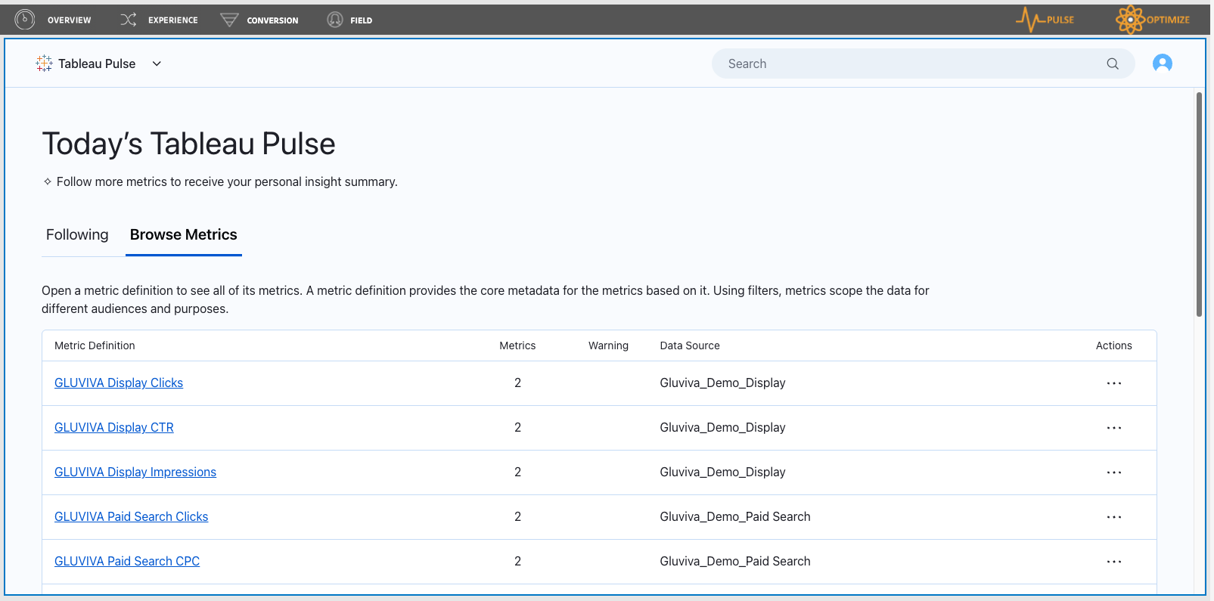

Click into each desired metric and click “Follow” for the desired time-period to add to “Following” on the home screen.

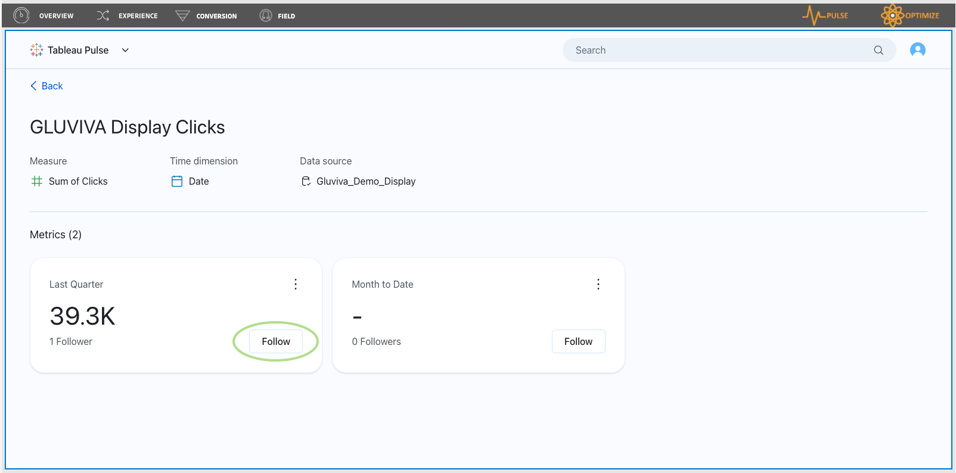

The selected metric will now appear in the “Following” section on the main Pulse view. After following a metric(s), that metric will always appear on the Pulse Homepage. There will be a KPI callout of the value, a trend line, a comparison from the prior time period, and a quick-hit insight. The Pulse Home will show these details for the entire collection of metrics that the user is following.

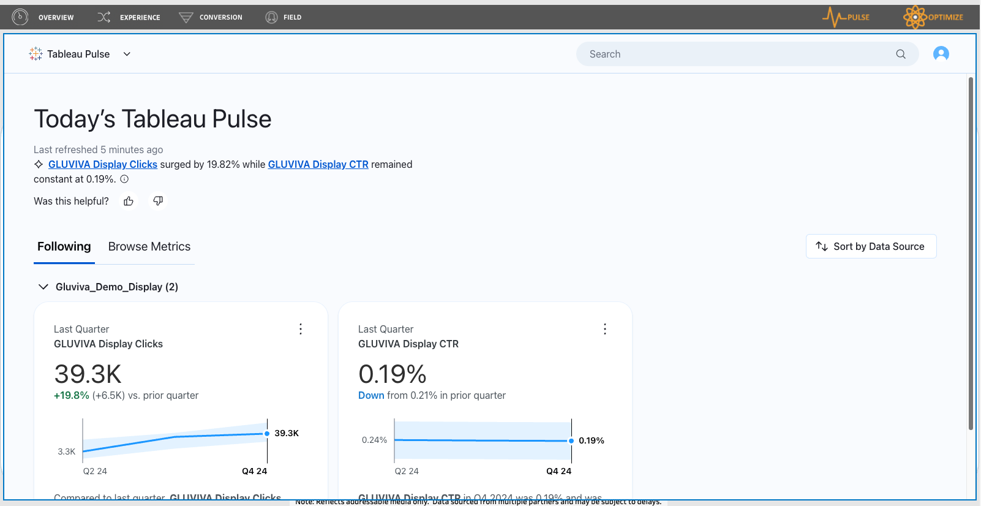

Users can click into each metric that’s set as “Following” to do a deeper dive into a metric or discontinue following by clicking the “Following” button. This will open up a much more in-depth analysis of the metric. The user will be able to see more insights, type in a question of interest, and see additional breakdowns of the metric.

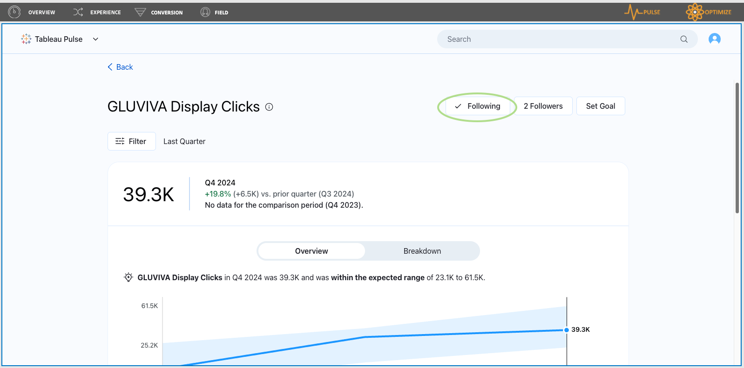

The Search feature can be used to find a desired metric ***if that data is included in Pulse*.**

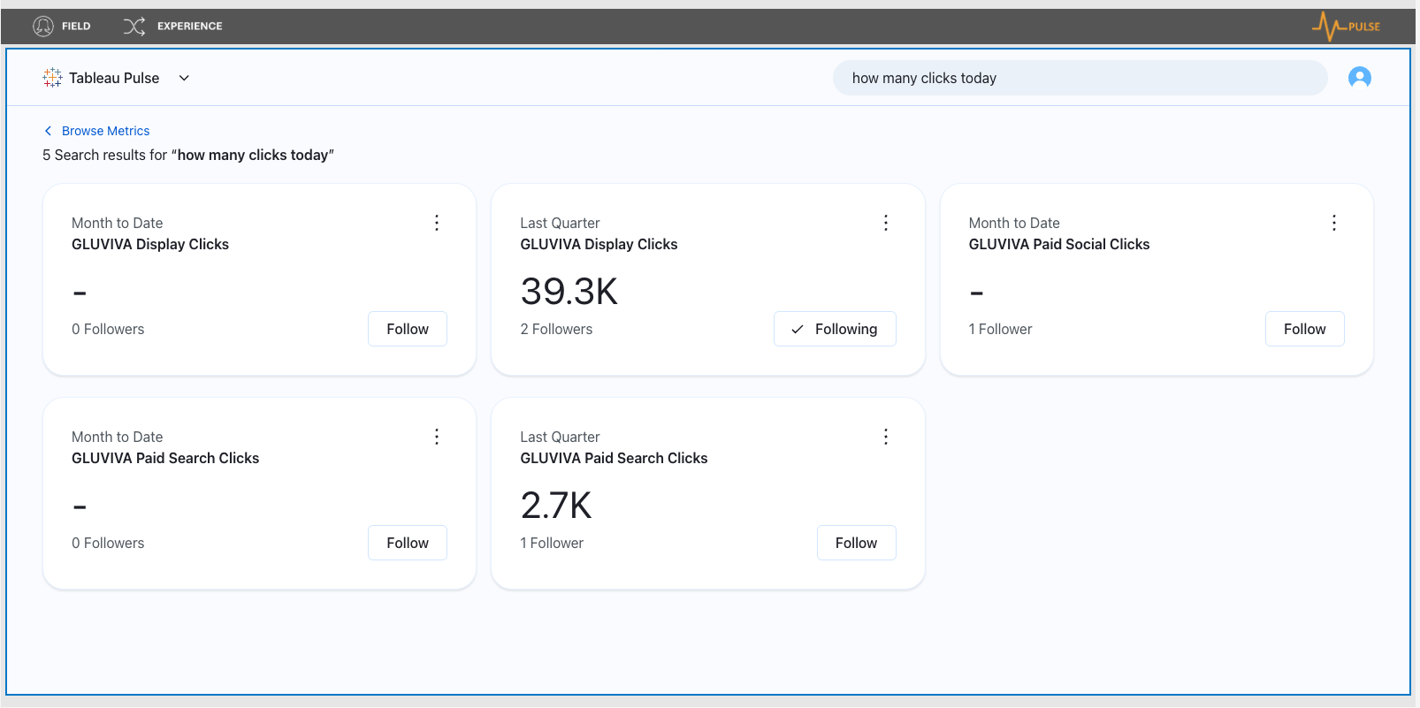

Pulse will populate results and allows users to “Ask” a question on the data, and also provides predicted questions to click on for further data insights.

**Customizing your ‘Pulse’ digest**

Tableau Pulse will automatically send insights via a summarized digest based on metrics the user is following. Users can determine the method they want to receive (email format) and the frequency they want to receive (daily, weekly, or monthly).

To customize, open ‘Pulse’ and click on your Account icon in the top right corner and select “Preferences”.

A pop up will appear as shown below:

Simply select how you want to receive your ‘Pulse’ digest (email) and the frequency you wish to receive (Daily, Weekly, or Monthly).

Click “Save”, and you’re all set!

**IIIV. ORCHESTRATE Optimize Feature**

**What is ORCHESTRATE Optimize?**

ORCHESTRATE Optimize, powered by Salesforce Einstein and Tableau Einstein Discovery, is an AI-powered analytics tool designed to uncover insights and make predictions based on complex data sets. Using machine learning and pharma specific models proprietary to EVERSANA, it helps identify patterns and key factors that influence outcomes—in this case, maximizing the number of prescriptions written by healthcare professionals (HCPs).

ORCHESTRATE Optimize supports the goal to increasing prescriptions by:

* **Predicting Prescription Outcomes:** AI helps us understand which factors (calls, samples, talks) are most likely to lead to increased prescriptions.
* **Identifying Key Drivers:** By pinpointing the activities that correlate strongly with higher prescription numbers, we can refine our marketing strategies.
* **Optimizing Marketing Efforts:** With a focus on high-impact engagement activities, we can maximize HCP interactions to improve prescription outcomes.

This dash leverages ORCHESTRATE Optimize to analyze key engagement metrics, which collectively contribute to the primary goal of maximizing prescriptions. By analyzing call frequency, sample distribution, and talk attendance, the model identifies the drivers that most significantly impact HCP behavior, helping us to:

* **Enhance Call Targeting:** We can prioritize calls to HCPs predicted to have the highest likelihood of increased prescription activity.
* **Refine Sample Allocation:** Insights into sample effectiveness allow us to target HCPs who will most benefit from receiving samples, boosting prescription likelihood.
* **Drive Talk Attendance:** By focusing outreach on HCPs likely to attend and benefit from talks, we can increase their engagement and subsequent prescriptions.

### **How to use ORCHESTRATE Optimize**

In the top right corner of the dashboard, click the button labeled **'Optimize'**.

This button provides direct access to the AI model results, which display specific recommendations and predicted outcomes based on the latest data.



By clicking *'Optimize'*, you can:

* View a summary of the key drivers that AI has identified.
* See suggested engagement activities and their expected impact on prescription outcomes.
* Access recommendations on call targeting, sample distribution, and talk attendance to improve overall campaign effectiveness.

Using this feature, you can quickly implement ORCHESTRATE Optimize’s AI data-driven suggestions, enhancing the campaign’s ability to achieve the ultimate goal: maximizing prescriptions.

### **Reading ORCHESTATE Optimize results**

The dashboard provides a visual representation of insights and predicted outcomes from ORCHESTRATE Optimize. Key metrics and visualizations are available for quick reference. This guide will show how the dashboard is structured, including:

* **Overview of Key Metrics:** Displays the impact of calls, samples, and talks on prescription outcomes.
* **Engagement Breakdown:** Visualizations of HCP engagement by activity type.
* **Predicted Impact on Prescriptions:** Graphs and charts showcasing the predicted increase in prescriptions based on optimized engagement strategies.

The **Top Predictors** section identifies metrics that currently impact prescription outcomes. Each predictor has a corresponding arrow indicating its impact.

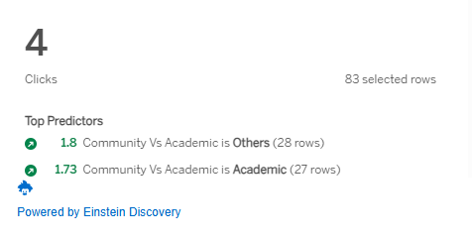

* **Green Upward Arrows**: These indicate metrics currently associated with an increase in prescription outcomes. For example:
  + **1.8 Community vs. Academic**: When this field is Other, it increases prescription outcomes 1.8 for these 28 rows.

These insights suggest where improvements could be made.

The **How to Improve This** section recommends actions to increase prescription outcomes.

* **Green Upward Arrows**: These arrows indicate where adjustments to key metrics could lead to increased prescription rates:
  + **2.71 Change SUM (DETAILED CALLS TOTAL) from 36 to 92 (28,828 rows)**: Increasing Detailed Calls Total to 36 - 92 could have a significant positive impact, suggesting that detailed calls are a strong predictor of higher prescription rates.
  + **0.54 Change SUM (TOTAL SAMPLES SHIPPED) from 37 to 207 (1,232 rows)**: Increasing the Total Samples Shipped to 37 - 207 could moderately boost prescriptions, indicating the positive influence of higher sample distribution on HCP prescribing behavior.
  + **0.14 Change SUM (COMPLETED CALLS TOTAL) from 52 to 65 (160 rows)**: A smaller increase in Completed Calls Total to 52 - 65 would have a minor positive impact, showing that while completed calls are beneficial, they are less impactful compared to detailed calls and samples.

These recommendations guide you toward actions that can maximize prescription outcomes:

* **Emphasize Detailed Calls**: Detailed calls appear to have the highest potential impact on prescriptions, making them a priority for optimization.
* **Increase Sample Counts**: Moderately increasing sample distribution could improve prescription rates, indicating that sample availability correlates positively with prescribing behavior.
* **Optimize Completed Calls**: While they contribute positively, completed calls may not be as impactful as detailed calls and sample distribution, so these should be adjusted accordingly.

### **How to access Salesforce Einstein for ORCHESTRATE Optimize**

#### Create a Salesforce account and password

Step 1: You will receive a Welcome Email asking you to verify your account. Click **'Verify Account'.**

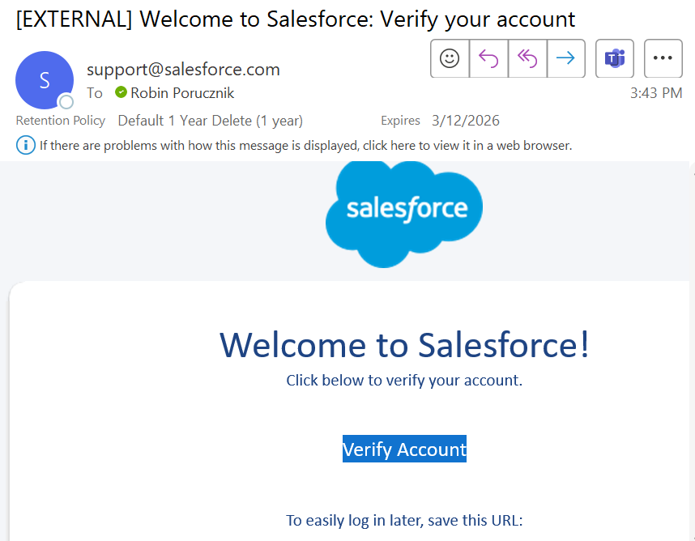

Step 2: A pop-up will appear, click on **'Reset Password'.**

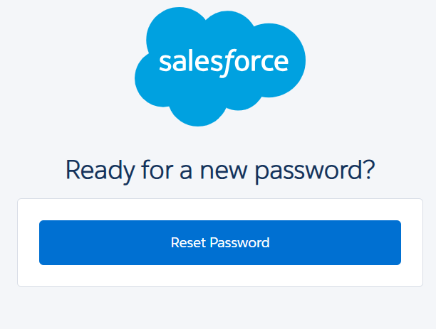

Step 3: Enter a password and security question.

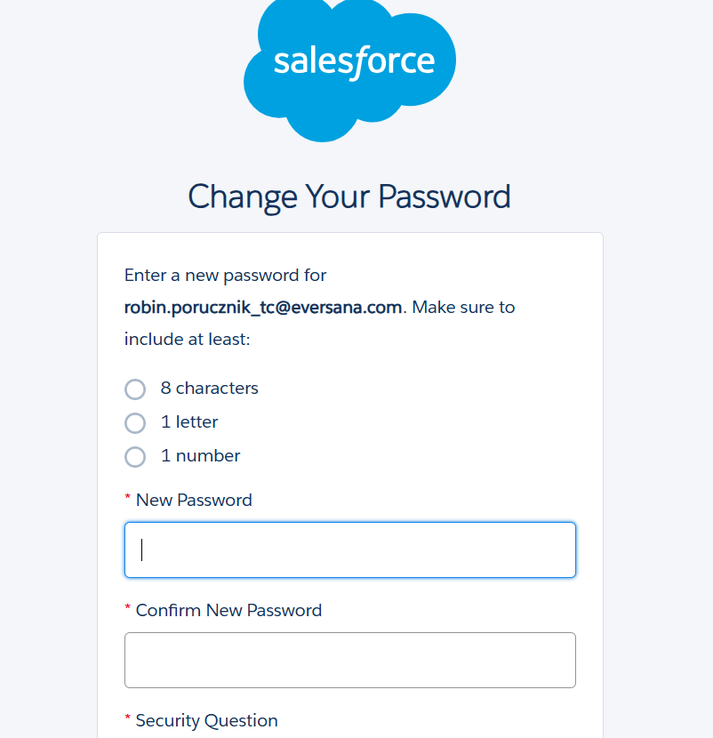

#### Connect Salesforce to the dashboard

Step 4: Click on the top right icon with your initial, then click **'My Account Settings'.**

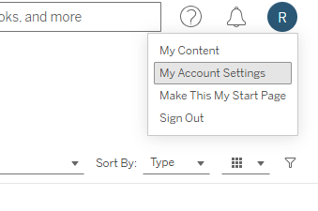

Step 5: Click **'Add'** next to Salesforce.

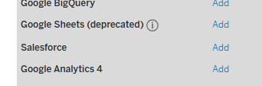

Step 6: A pop-up will appear with a pre-populated URL. Click the **'Add'** button.

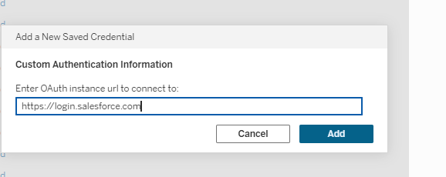

Step 7: Login with your Salesforce credentials. It may ask you to verify on your Authenticator app, follow those instructions and type in the numeric code from the app on your phone.

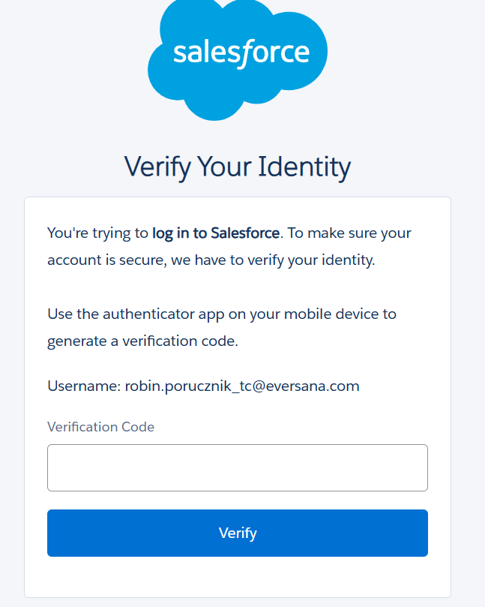

Step 8: A pop-up will appear to allow access. Click **'Allow'.**

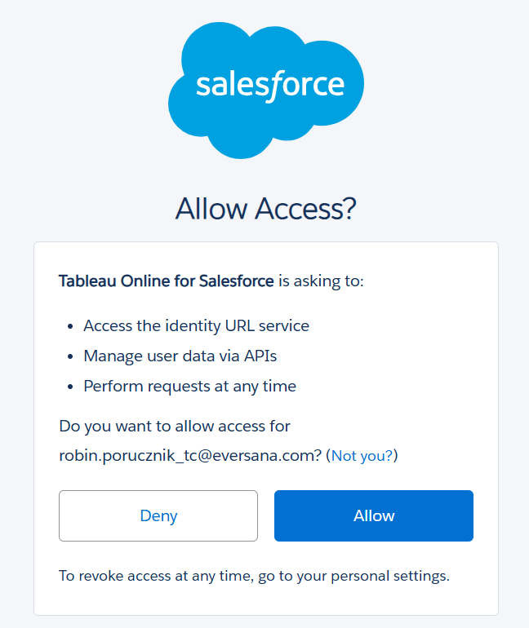

Step 9: If your connection looks like this in your account settings, then you are all set!

